|  |  |
| --- | --- |
|  | **BAHRIA UNIVERSITY,**  **(Karachi Campus)**  *Department of Software Engineering*  **ASSIGNMENT#01 – Fall 2021** |

Course Title: **Probability & Statistics** Course Code: **GSC-112**

Class: **BSE-3(B)** Deadline: **15-Dec-2021**

Course Instructor: **Engr. M. Adnan Ur Rehman** Max. Points: **20 Points**

|  |  |  |
| --- | --- | --- |
| **GROUP MEMBERS INFORMATION** | | |
| **S.No.** | **Student Name** | **Enrolment#** |
| 1 | TALHA ZAFAR | 02-131202-080 |
| 2 | MUHAMMAD MUAZ SHAHZAD | 02-131202-081 |
| 3 | SHAHAB TAHIR | 02-131202-011 |
|  |  |  |

**Question 1:**

An electric power company, based on renewable energy, needs to install their wind turbines on the windiest location in Australia. You need to find out that location.

**Procedure:**

* Break the given data into number of cities (49 total).
* Calculate the average of wind speed at 9AM after deleting the empty cells.
* Calculate the mean of wind speed at 3AM after deleting the empty cells.
* Calculate the average of the wind speed mentioned in above two steps.
* Repeat steps 2,3 and 4 for all the locations.
* Determine the location having greatest wind speed.

**SOLUTION**:

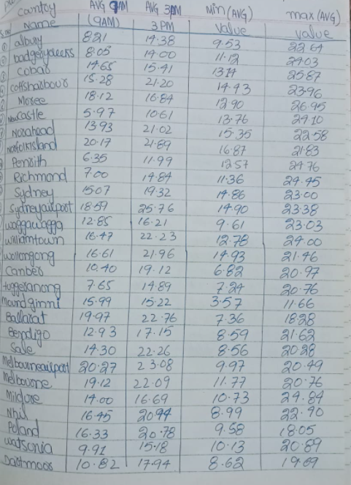

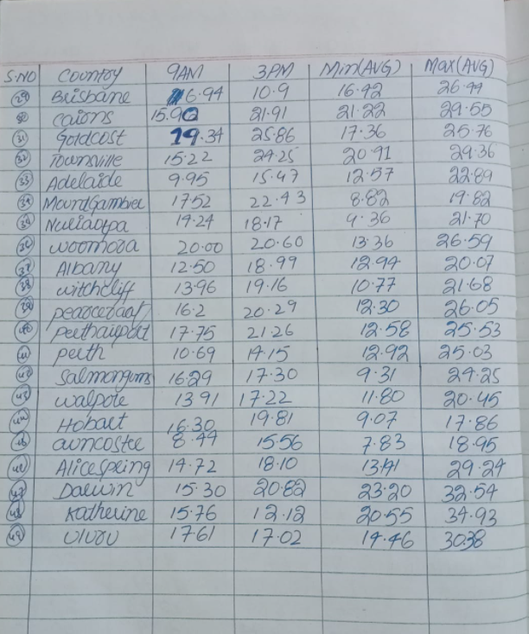

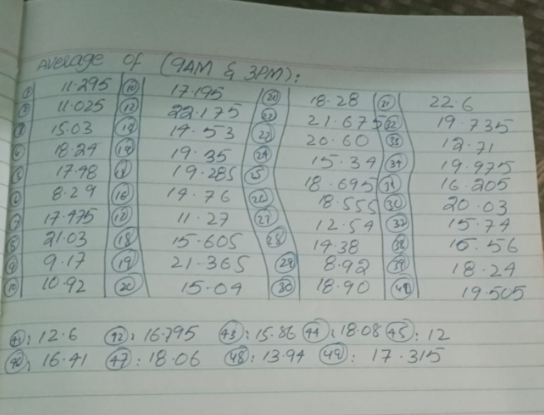

**ANSWER:**

According to the given data the windiest location is Gold Coast in Australia with the speed of 22.60km/h.

**Question 2:**

It is true that greater the difference between minimum and maximum temperature per day, greater will be the chance of getting seasonal flu. Find out the location where there is minimum chance of getting seasonal flu.

**Procedure:**

* Break the given data into number of cities (49 total).
* Delete the empty cells and calculate average of all the values of minimum temperature values.
* Delete the empty cells and calculate average of all the values of maximum temperature values.
* Calculate the difference between minimum temperature mean from max temperature mean, subtract.
* Repeat the steps 2,3 and 4 for all locations.
* Identify the locations having lowest difference.

**SOLUTION**:

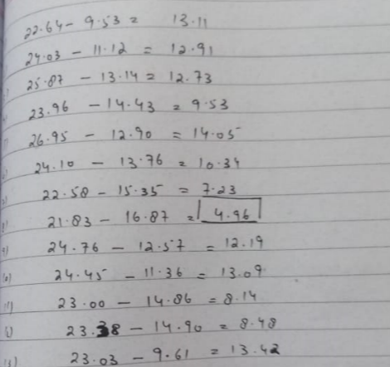

**ANSWER:**

With the difference of 4.95°Celsius between average maximum and average minimum temperature, Norfolk Island has the minimum chance of getting seasonal flu.

**Question-3:**

Find out the location having almost same temperature comparatively throughout the given data.

**PROCEDURE:**

* Break the given data into number of cities (49 total).
* Calculate the average of the minimum temperature values and maximum temperature values, delete the empty cells.
* Calculate the sample variance of all the average values finding in above step 2.
* Repeat the steps 2 and 3 for all locations.
* Determine locations having lowest variance.

**ANSWER:**

Darwin has almost the same temperature comparatively throughout the given data of 4.19°C.

**Question-4:**

Apply statistical techniques and compare the result to find the location having unexpected wind speed.

**Procedure:**

* Break the given data into number of cities (49 total).
* Calculate the average of wind at 9 AM and at 3 PM, delete all the empty cells and make third column of mean with the help of 9AM and 3PM
* Calculate the average of the third column.
* Calculate the median of the third column.
* Find the difference between the median from mean.
* Repeat the steps 2,3,4 and 5 for all locations.
* Determine the locations with the highest difference.

**ANSWER:**

Newcastle has the unexpected wind speed with a difference of 2.43.